Rubric SAR for B.Sc (Hons) Degree Program of

DEPARTMENT OF RURAL SOCIOLOGY
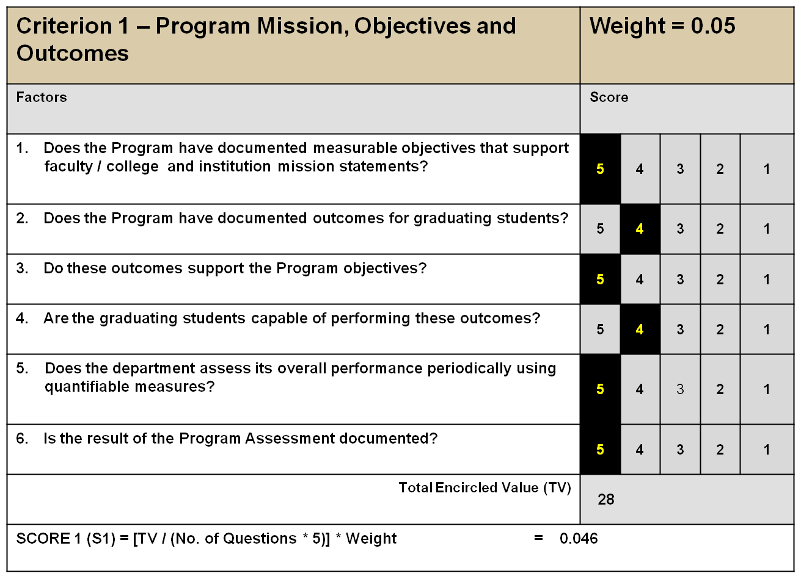
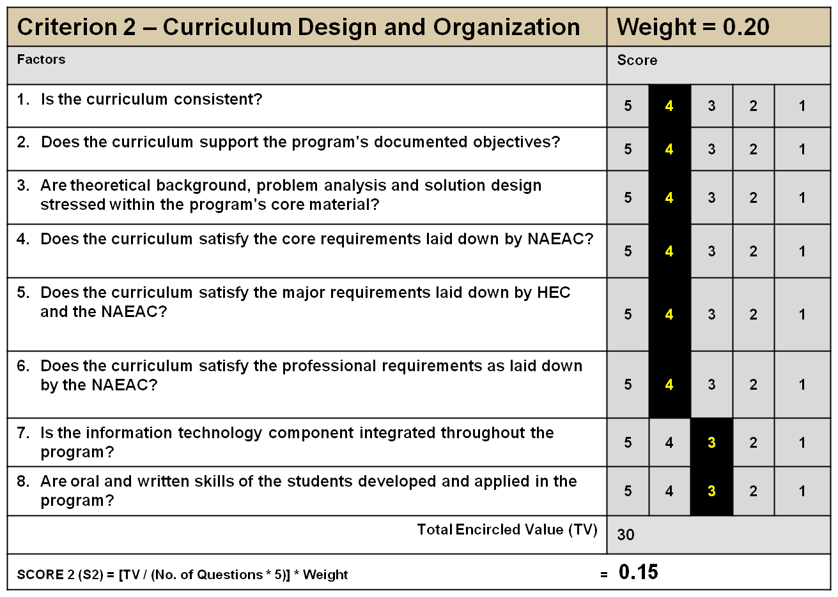
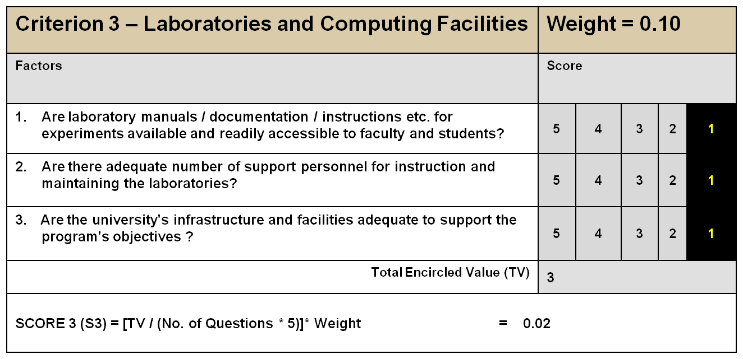
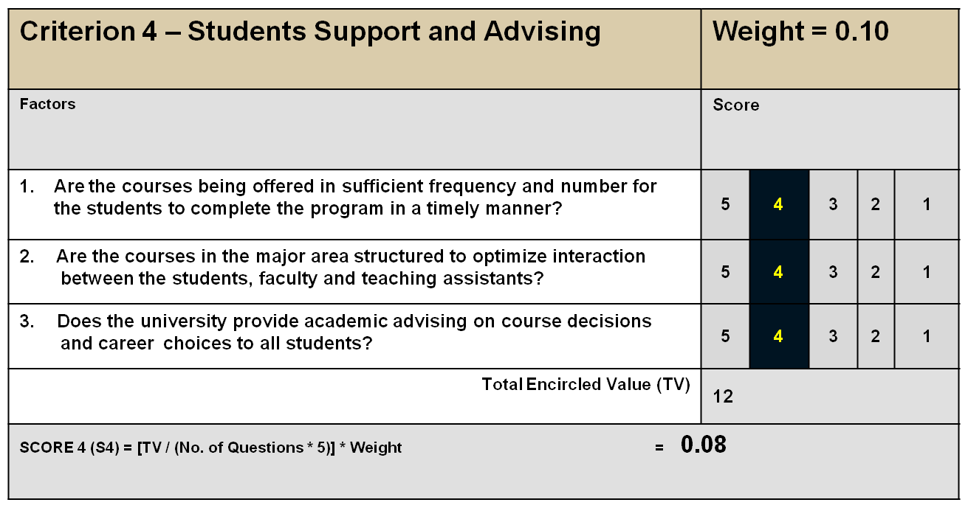

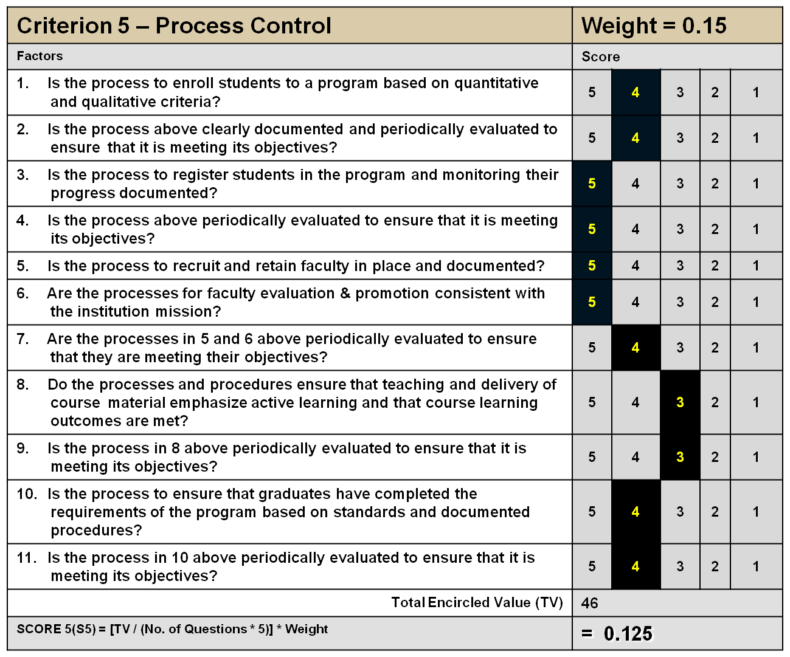

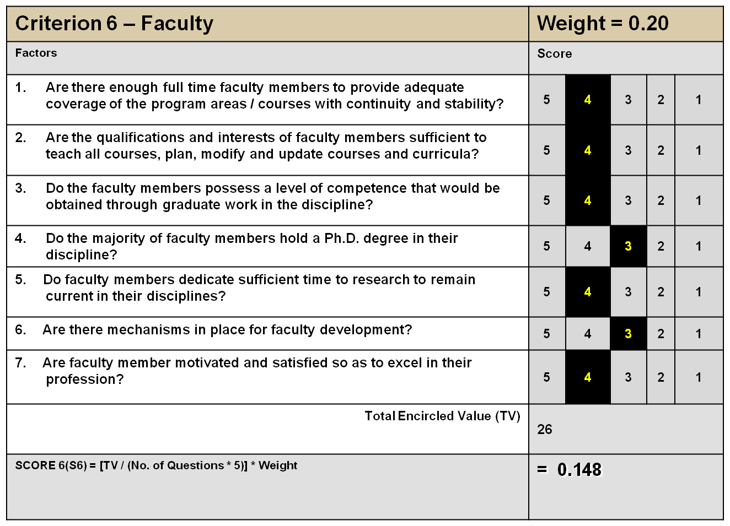
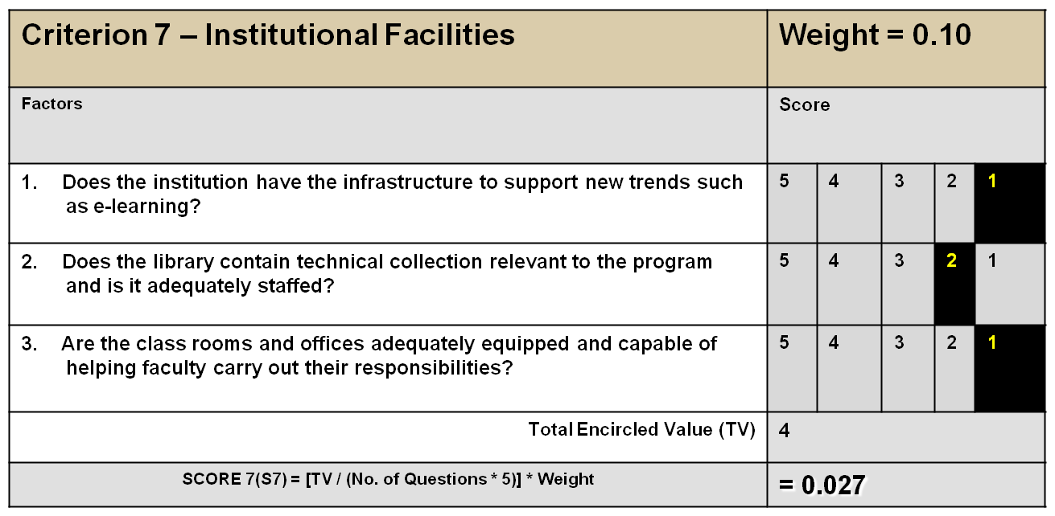
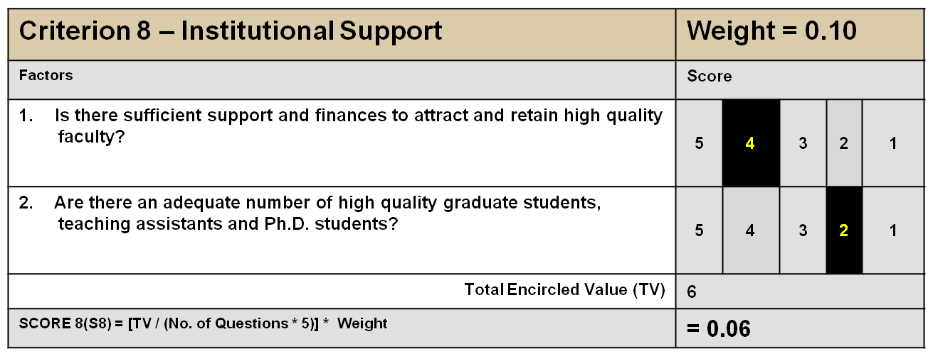
OVERALL ASSESSMENT SCORE:
S1 + S2 + S3 + S4 + S5 + S6 + S7 + S8 = 0.66
REMARKS:
- The department has no computer lab.
- The department is deficient in space for accommodating students (class rooms) and faculty (offices).
- At present the department is running its official business with just 3 offices and one class room at its disposal, while running a full fledge B.Sc (Hons) and M.Sc (Hons) program leading to PhD. It is worth mentioning here that the department has also to its credit two year MA (SSEP) program.
- The department is ready to launch a Ph.D program but is facing shortage of qualified faculty.
- The students have limited exposure to concerned communities due to limited field visits.
- Non availability of ministerial staff.
- Limited financial resources, and difficult mechanism for its acquisition.
- Limited scholarships for needy students.

